**4. Mini-Test**

1. With Vector Clocks you can differentiate between events which may occur in different processes and thus you obtain the strong clock consistency condition: a<b ↔ C(a) < C(b)

1. Two Vector Clocks are causally dependent if  
   1. The corresponding events are all different and  
   2. All events of one Vector Clock are smaller or equal than the corresponding events of the second one.
2. The tick happens before sending the message.  
   If we let the tick happen after sending an event, we couldn’t differentiate if an event occurs earlier. For example:

100

100

010

001

000

000

000

000

P1

P2

P3

Here P1 can’t differentiate if P2 or P3 events occur first, although it is clear that P3 causally depends on P2.

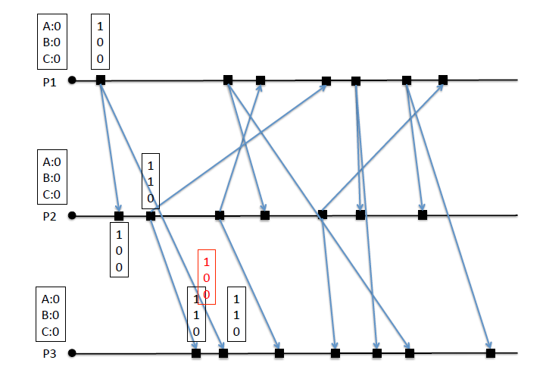

200

220

220

320

4201

430

120

220

230

430

330

120

230

330

330

430

100

110

110

200

200

120

230

320

420

420

230

320

120

1. The paper proposes a concept of “Dynamic Vector Clocks”, an extension of vector clocks, which can be used in a System with changing numbers of processes.